Example Process

The process consists of:

- Well-Stirred mixer tank
- Tubular reactor
- Gas absorption column

A gas-phase reaction A + B → 2C is carried out in the tubular reactor. The reactor’s product is fed to the countercurrent absorption column where the component C is partially absorbed in the liquid phase. The remaining gas is recycled in the well-stirred mixer with fresh feed.
ψ_{i}^{e}

ζ
Gas Absorber

λ

φ_{i}^{e}
φ_{i}^{m}
Mixing
Tank
Tubular Reactor

The following are the dimensionless mass-balance equations of motion governing the dynamic behavior of the process:

Tubular Reactor:

Mass Balance
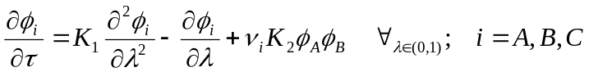

Boundary Conditions
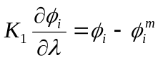 at 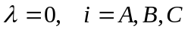
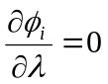 at 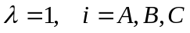

where the stoichiometric coefficients for the mass balance are 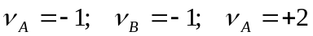, and 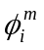is the reactor feed (from the mixer).

The constant values K₁ = 0.1, and K₂ = 3.0.

Gas Absorber

Mass Balance
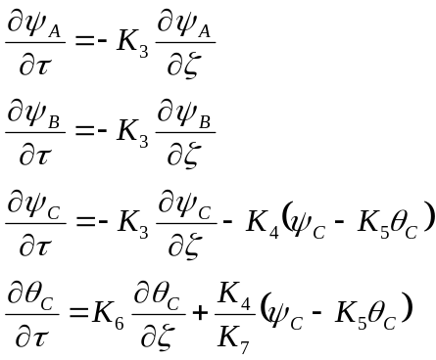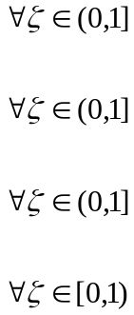

Boundary Conditions
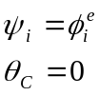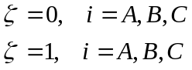

The constant values K₃ = 0.1, K₄ = 20.0, K₅ = 10.0, K₆ = 0.003, and K₇ = 75.0.

Mixing Tank

Mass Balance

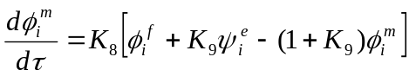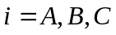

The constant values K₈ = 30.7, and K₉ = 0.5.

